Coaches Training Institute June 2, 2012
4000 Civic Centre Drive, Suite 500
San Rafael, CA 94903

To Whom It May Concern:

RE: Linda Langley

I have known Linda Langley both personally and professionally for over thirty years. She is a highly skilled and respected health care practitioner; a strong and natural leader and one who approaches all tasks, projects and challenges with passion and dedication. It is a privilege to support Linda in her pursuit of Front of the Room Leadership with the Coaches Training Institute (CTI).

I met Linda in the early eighties when we were both actively involved in the Canadian Physiotherapy Association (CPA). Linda held a number of leadership positions in the CPA over many years while building a successful business in Atlantic Canada, acting as the lead negotiator for private practice funding with a number of agencies and raising a family. She is the consummate multitasker who has always focused more on what is best for her profession and clients’ needs than personal gain; a rare and commendable quality in a private market.

Linda and I sold our respective businesses to LifeMark Health, now Centric Health, in 2000. We have shared many exciting opportunities and unique challenges since then. I have observed, with admiration and respect how Linda has developed her region and emerged as a highly respected leader both in the company and with her peer group of provincial Vice Presidents.

It has been a delight for me to witness Linda’s passion and excitement over her leadership training with CTI and becoming a trainer herself. Her regional team has benefited from leadership development workshops and other senior employees have expressed appreciation for and confidence in her personal coaching skills. I look forward to Linda adding Leadership Training to the Centric Health Professional Development Program.

Linda is a visionary, a mentor, a powerful negotiator and a great communicator. She demonstrates strong and ethical personal values in everything she does. She enjoys trust and respect both within and outside this company. These leadership qualities coupled with her sound business acumen make Linda of tremendous value to this company.

Yours truly,
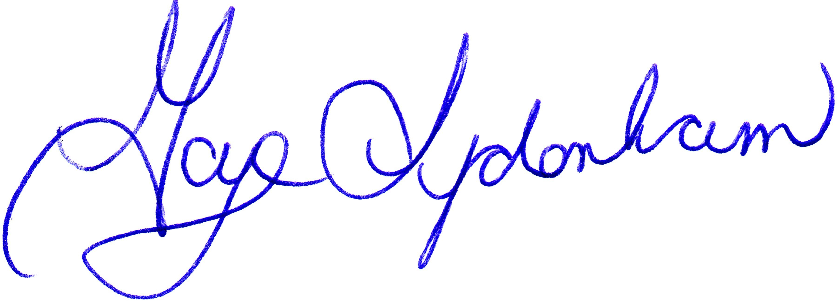

VP Accreditation & Professional Development

